# COMP 7500/7506-Lecture 04: Message-Passing Systems

**🟊: >85%, 🟊🟊: 70-85%, 🟊🟊🟊: 55-70%, 🟊🟊🟊🟊: 40-55%, 🟊🟊🟊🟊🟊: < 40%**

**🟊🟊 Exercise 1 (Menti):** What are the basic two operations of a message passing system?

**🟊 Exercise 2:** Please extend the two prototypes for direct communications.

**🟊🟊🟊 Exercise 3 (Menti):** Suppose you have implemented a message passing mechanism on a shared-memory system and a distributed-memory system, respectively. Which system is more scalable? Why? (30 Seconds)

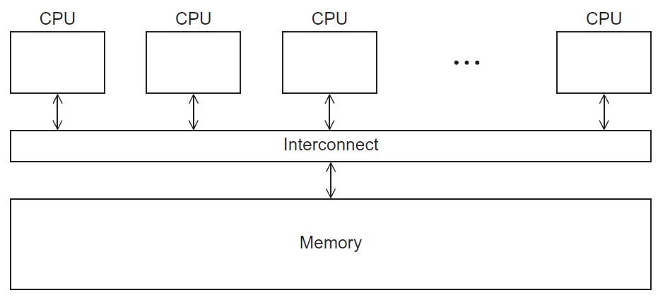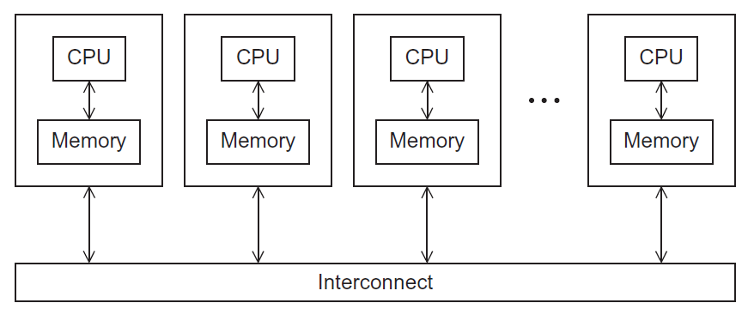

A) Shared-Memory System B) Distributed-Memory System

C) They are equally scalable D) Scalability can’t be measured

**🟊🟊🟊 Exercise 4 (Menti):** How should communicating processes be associated with a link in direct communication? Why? (30 Seconds)

1. A link is associated with multiple pairs of processes
2. A link is associated with exactly one pair of processes
3. A link should be associated with any pair of processes
4. A link is associated with a group of more than two processes

**🟊🟊 Exercise 5 (Menti):** Is a link unidirectional or bi-directional in direct communication? Why? (30 Seconds)

1. A link is unidirectional
2. A link is bidirectional
3. A link is neither unidirectional nor bidirectional
4. A link has a hybrid mode: either unidirectional or bidirectional

**🟊🟊🟊 Exercise 6 (Menti):** How should communicating processes be associated with a link in indirect communication? (30 Seconds)

1. A link is associated with multiple pairs of processes
2. A link must only be associated with exactly one pair of processes
3. No link should be associated with communicating processes
4. A link is associated with a group of two or more processes

**🟊🟊 Exercise 7 (Menti):** How many communication links should each pair of processes share? (30 Seconds)

1. Each pair of processes may share several communication links
2. Each pair of processes must share a single communication links
3. Each pair of processes must share two communication links
4. Each pair of processes must share three communication links

**🟊🟊 Exercise 8**: What are the four basic operations for indirect communication? (30 Seconds)

**🟊🟊 Exercise 9**: Please design the prototypes for the following two operations for indirect communication. (30 Seconds)

**🟊🟊🟊 Exercise 10**: There is a shared mailbox among P1, P2, and P3.

Suppose P1 sends a message to the mailbox, both P2 and P3 receive. Who gets the message? (30 Seconds)